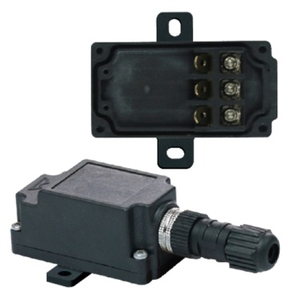

**Type Y3A1**

**Sub-miniature enclosure for temperature sensor, level sensor, electronic printed circuit or cartridge heater. Removable wall mounting bracket.**

Plastic enclosures, these enclosures are in fiberglass reinforced PA66.

Size (mm): 61 x 33 x 30.

Volume (cm3): 52.

Ingress protection: IPX4.

Level of impact resistance: IK8.

Suitable for: Temperature sensor, Level sensor.